October STEM
Hurricanes!
Imagine a force that can toss boats around like toys, wash away bridges, and create waves as high as 18 feet. With fierce winds and torrential rains, hurricanes can do all of these things. For centuries people did not know when a hurricane was coming.

Standards

Challenge
Create a working model of a water cycle that you will then present demonstrating the different stages
Constraints
- Water cycle must be able to show condensation, evaporation and precipitation
- Must be explain how a hurricane has a complete water cycle

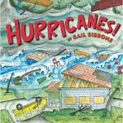
Materials
- Script
- Background
- Water cycle model
  - Cup
  - Saran wrap
  - Rubber bands
Tools
- iPad
- Scissors

